DYNATRACE QUERY LANGUAGE
- Introduction to Dynatrace Grail: - Grail is the Dynatrace database designed explicitly for observability data. It acts as single unified storage solution for logs, metrics, traces, events, and more.
- Data leaks were maintained by all the process was requested.
- Data Warehouse maintained structured or semi-structured data copied from multiple sources it’s use for reporting the data and analysis purpose.
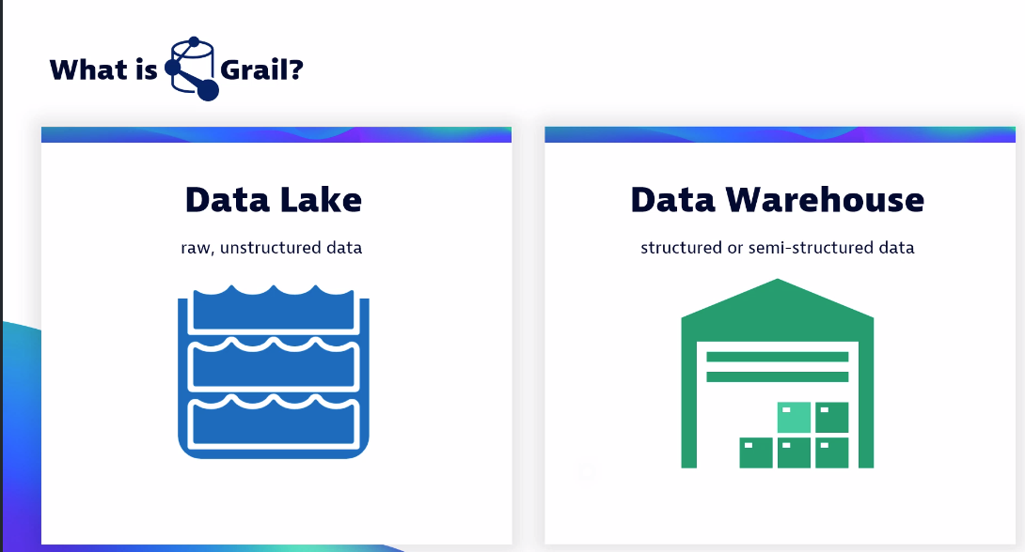
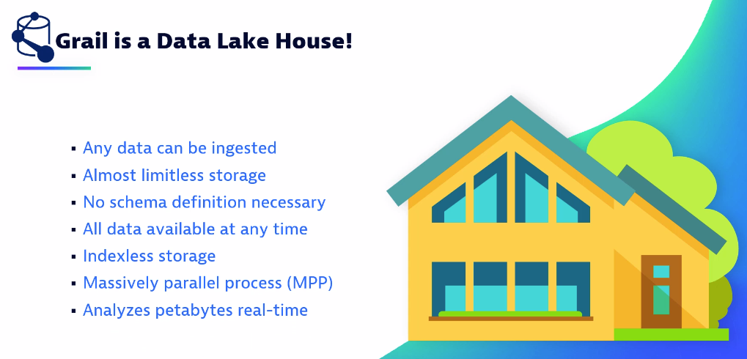
- Grail builds specifically for ingest and process, retain and analysis.

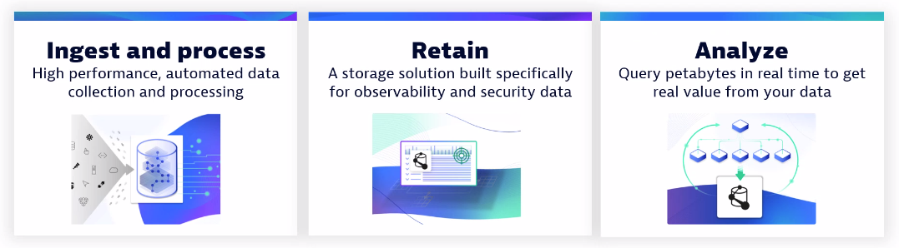
- Grail Data Model and Permissions: -
- Grail Data Model:- Dynatrace Grail Data Model is a powerful analytical framework provided by Dynatrace, a leading software intelligence platform. It is designed to handle and analyze vast amounts of data collected from various sources within an enterprise's IT ecosystem.

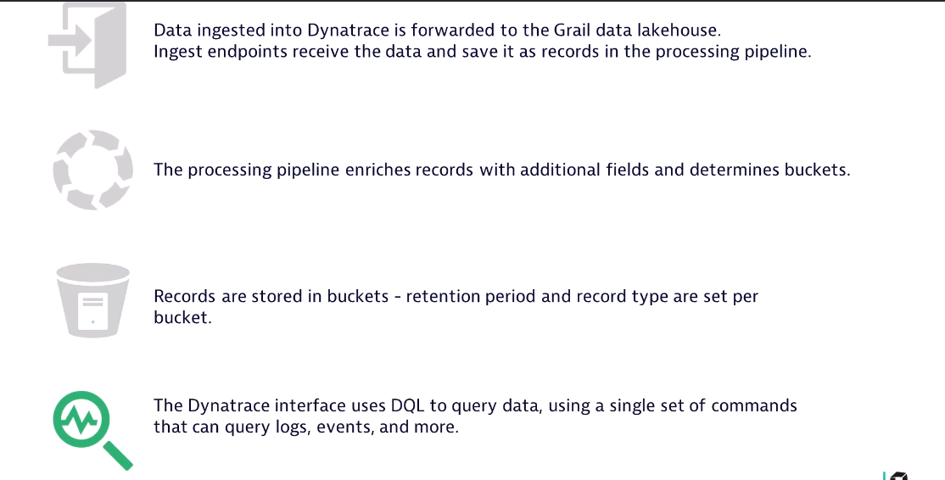
- We can use the buckets in dynatrace to store the data or queries for specific dashboards or users.
- And we can maintain data folders in the buckets as our requirement.
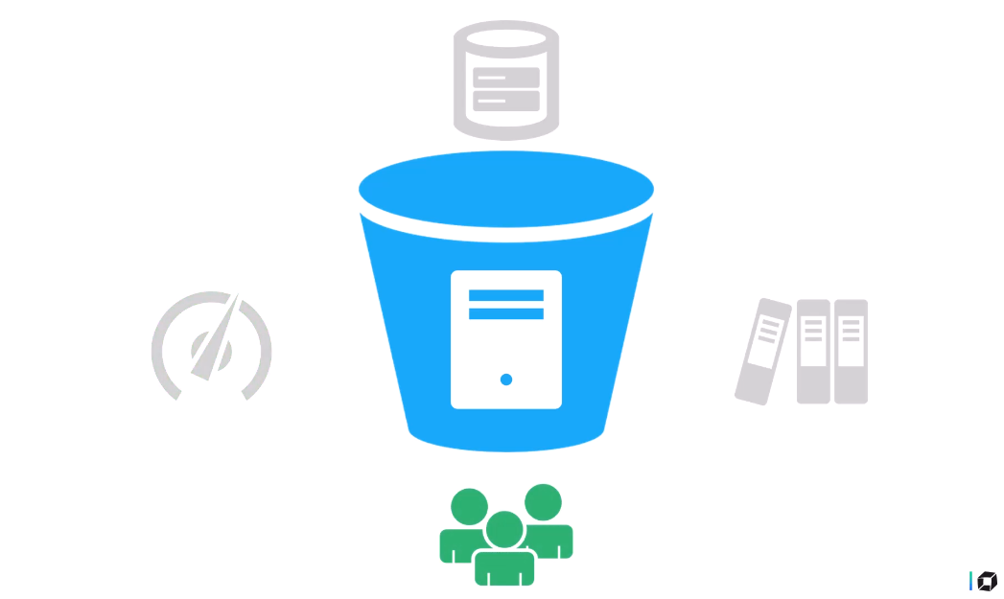
- There are two types of buckets over there in the dynatrace data models, one that created by dynatrace and maintain itself by dynatrace and second that created by customer or users and maintain our self.
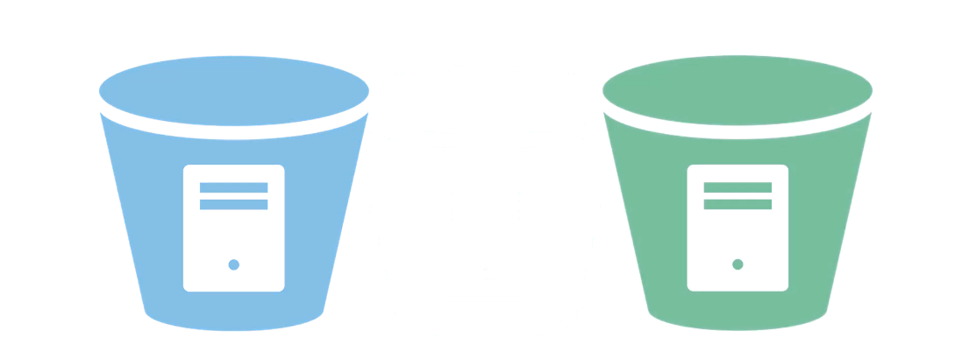
- These are buckets created and managed by dynatrace, users can not modify them.
- Default buckets name start with default_ and systems buckets name start with dt_
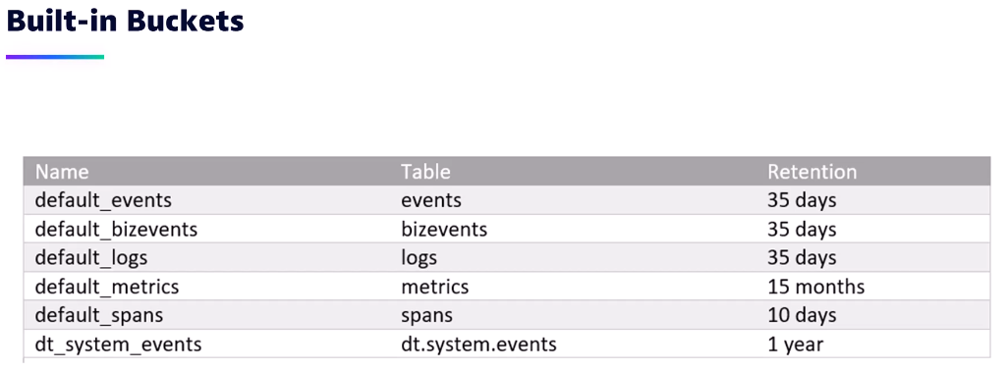
Grail data permissions: - Permissions are typically managed through user roles and access controls.
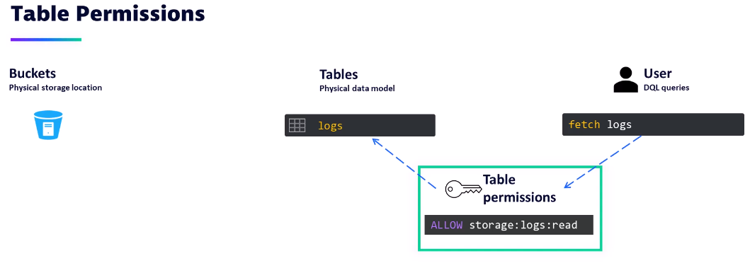

- These are the supported table permission in the dynatrace we can use as per requirement like read write and modify.
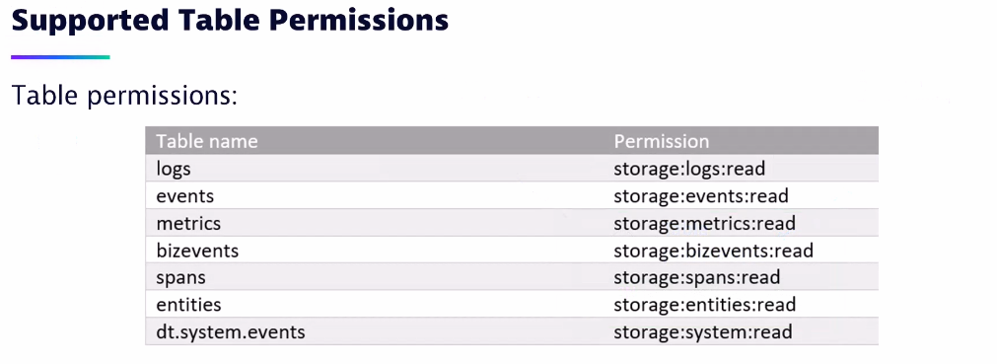
- Introduction to Dynatrace Query Language: - Dynatrace Query Language (DTQL) is a powerful querying language designed for analyzing and extracting data from the Dynatrace platform. It allows users to perform advanced data analysis and aggregation to gain insights into application performance, infrastructure monitoring, and user behavior.
- There are some key concepts and features of Dynatrace Query Language
Metrics, Entities, Time series data, Filtering and grouping and Functions and operators. 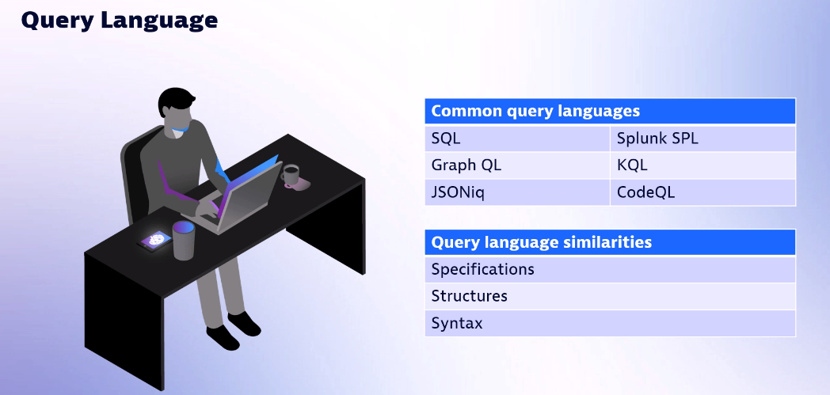

- With DQL you can refer calculations and sorting to get the result.
- In other query language we can use “where” command, in the dynatrace instead of that use “filter”
- We can check some of the basic query’s in below.
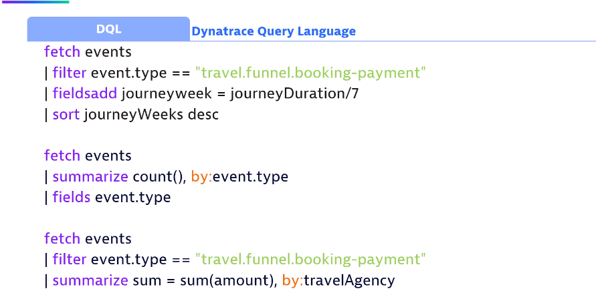
- Where will we use DQL: - Dynatrace Query Language (DTQL) is a query language specifically designed for interacting with the Dynatrace platform, which is a comprehensive monitoring and performance management tool used in the field of application and infrastructure monitoring. DTQL allows users to query and analyze data collected by Dynatrace to gain insights into application performance, identify bottlenecks, and troubleshoot issues.

- DTQL can be used in various scenarios.
Application performance monitoring, Infrastructure monitoring, Troubleshooting and root cause analysis, Synthetic monitoring, and Business analytics.
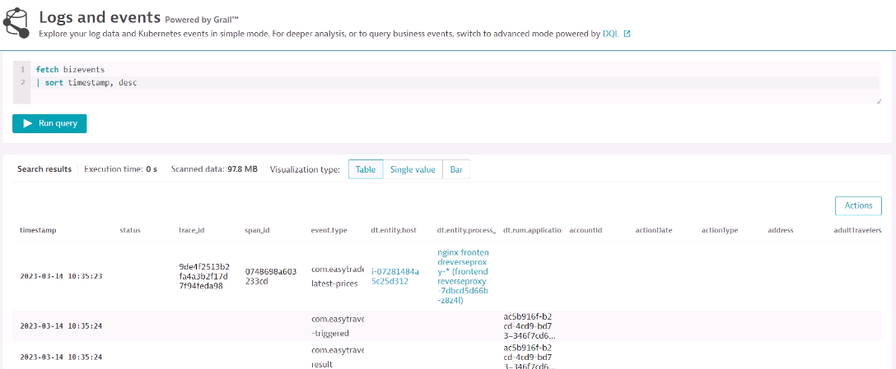

- Dynatrace Query Structure: - Dynatrace Query Language (DTQL) is used to query and analyze data in Dynatrace, a monitoring platform for cloud applications and infrastructure. DTQL allows you to retrieve specific metrics, events, and traces from your monitored environment. The structure of a DTQL query consists of several components.
- In Dynatrace Query Language (DTQL), the "FILTER" clause is used to narrow down the results of a query based on specific conditions. The "FILTER" clause allows you to apply additional filtering logic to the data retrieved from Dynatrace. It is like the "WHERE" component mentioned earlier in the query structure.

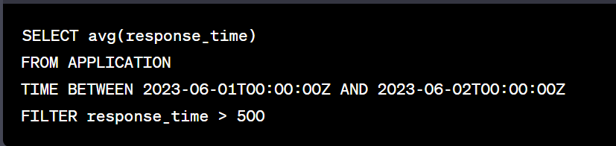

- SELECT , SELECT avg(response_time), SELECT useraction.count, SELECT timestamp, FROM, FROM APPLICATION and FROM PROCESS_GROUP_INSTANCE.

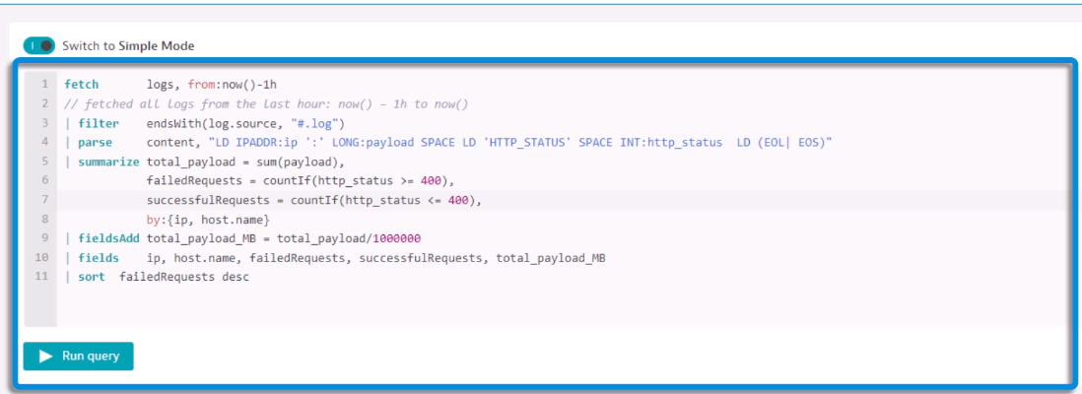
Common commands we used in query.
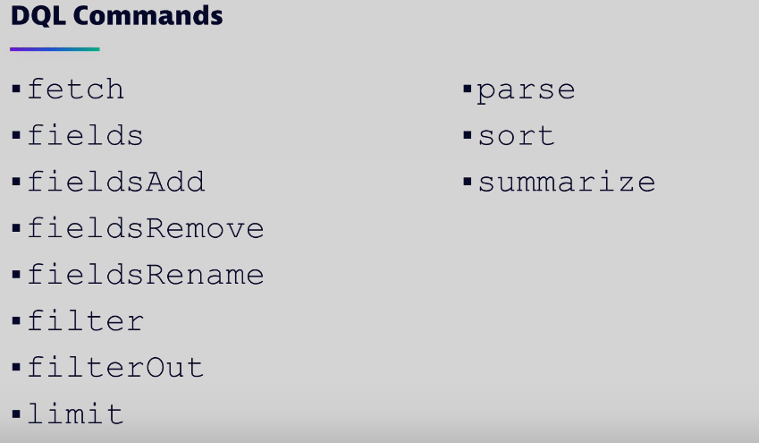

- There is ordered to write in the DQL queries.
Fetch the logs and commands like filter and filter out.
Function like summarize and sort and finally if needed we can use limit also.

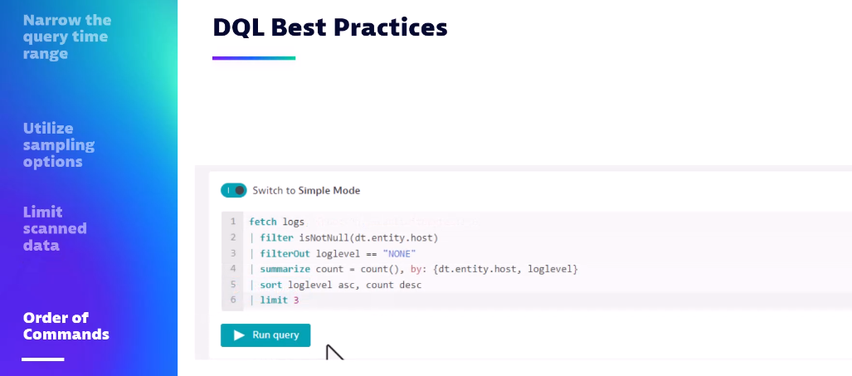

- NOTEBOOK: - Dynatrace Notebooks provide a collaborative environment where users can create and share interactive reports, visualizations, and analyses based on the data collected by Dynatrace. Notebooks enable users to explore and correlate data from various sources, including metrics, logs, traces, and custom data.
- Some key features of Dynatrace Notebooks include.
Data exploration, Visualization capabilities, Collaboration and sharing, Integration with Dynatrace data, and Automation and scheduling.
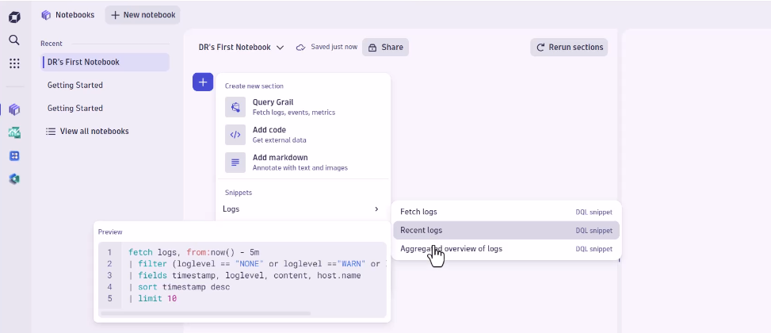
For more information, please follow the below link.
https://www.dynatrace.com/support/help/observe-and-explore/notebook

